SHIKHA BHARGAV
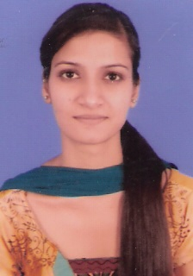
H.No. 970,Street no 3,harkrishan
Nagar,chheharta,amritsar-143001
Email bhargavshikha91@gmail.com
Mobl no: +91-9780840432

OBJECTIVE

Seeking a position to utilize my skills and abilities in the Industry that offers professional growth while being resourceful, innovative and flexible.

ACADEMICS

MBA (2012-2014) | Major –Finance Minor - Marketing from Guru Nanak Dev University Amritsar(aggregate of 6.53 cgpa)
B.Sc (computer Science)  (2012) | Computer Science from khalsa college for women Amritsar, affiliated to guru nanak dev university(aggregate of 57.91%)
XII (2009) | Non-Medical from holy heart presidency school (ISC), Amritsar. (aggregate of 73%)
Metric (2007) | Holy heart presidency school (ICSE), Amritsar. (aggregate of 79.81%)

TECHNICAL SKILLS

Operating System | Windows XP/Vista/Win7
MS Office | MS Word, MS PowerPoint, MS Excel
Language | c, c++.

TRAINING

- 6 weeks Training at canara bank ranjit avenue branch .amritsar.

ACHIEVEMENTS

- I have been part of of academic team of university business school.
- Participated and bagged first position in theatre items in campus fest.
- Participated and bagged first position in inter school recitation and declamation competition.
- Participated and bagged second position in inter school collage making competition.
- Achieved first position in skating .

PERSONAL PROFILE

Nationality | Indian
Date of Birth | Febraury 18,1991
Marital Status | Single
Languages Known | English, Hindi, Punjabi
Hobbies | Surfing internet,Listening Music,Reading Novels

SELF ASSESSMENTS

I am dedicated to my work and can put continuous efforts to bring out positive results. I like to accept challenges in life. A strong will power and rational approach are my additional assets.

Place :Amritsar Shikha Bhargav

